Problem Statement: Create a simple project with Jenkins connected to your GitHub repository. When a commit is made to your repo, automatically build must get triggered from Jenkins and the output must be shared via email."

Create New item, click and select pipeline, name it and select Ok

For configuring the pipeline, provide the source code under the git hub URL in the “Git Hub Project” section.

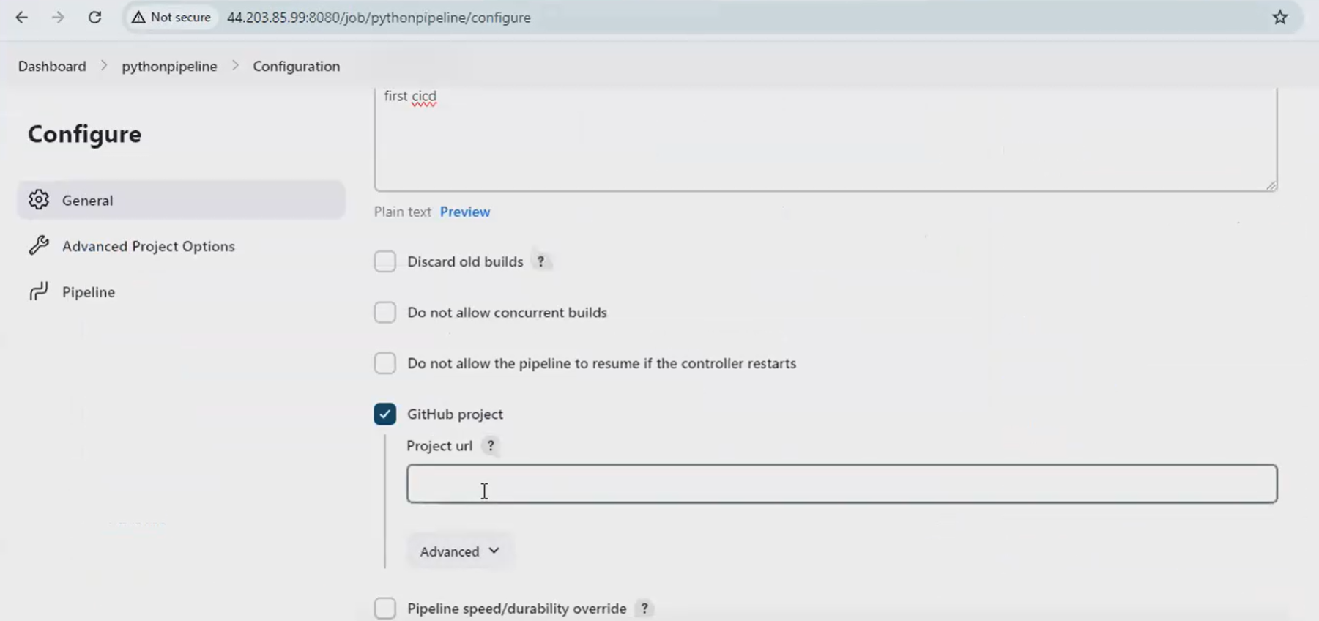

Check the checkbox stating “Git Hub hook trigger for GITScm polling”

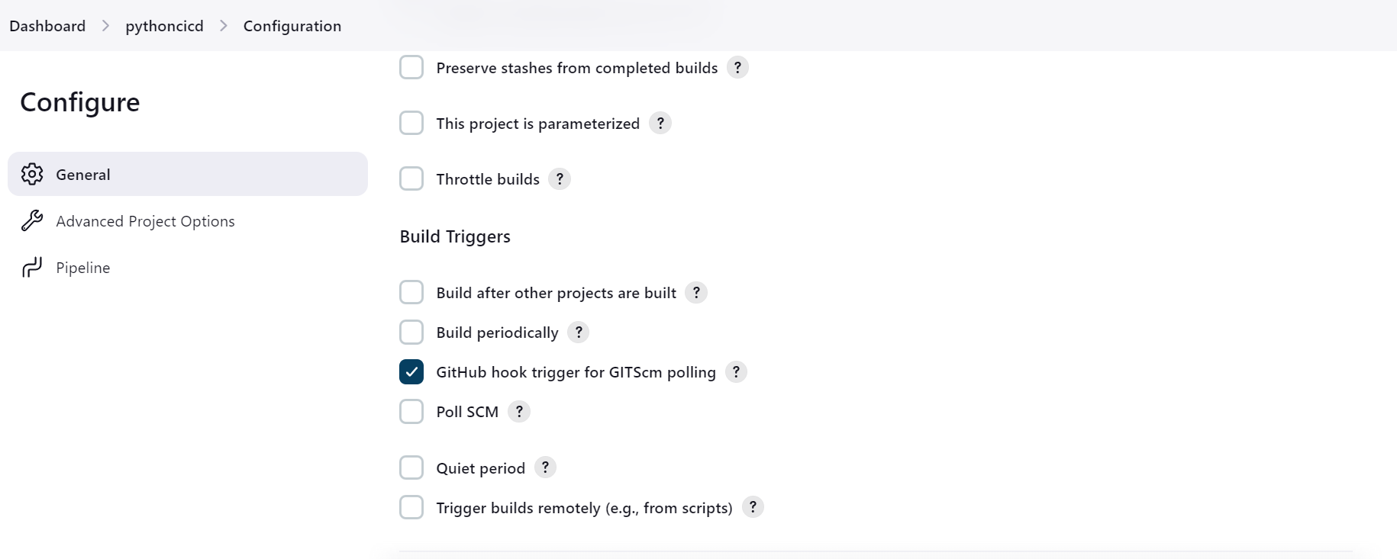

Select “Pipeline Script from SCM” if the Jenkinsfile is available in the Github or else we can write the sript there itself in the Jenkins app, give the name of the Jenkins file in the option Script path

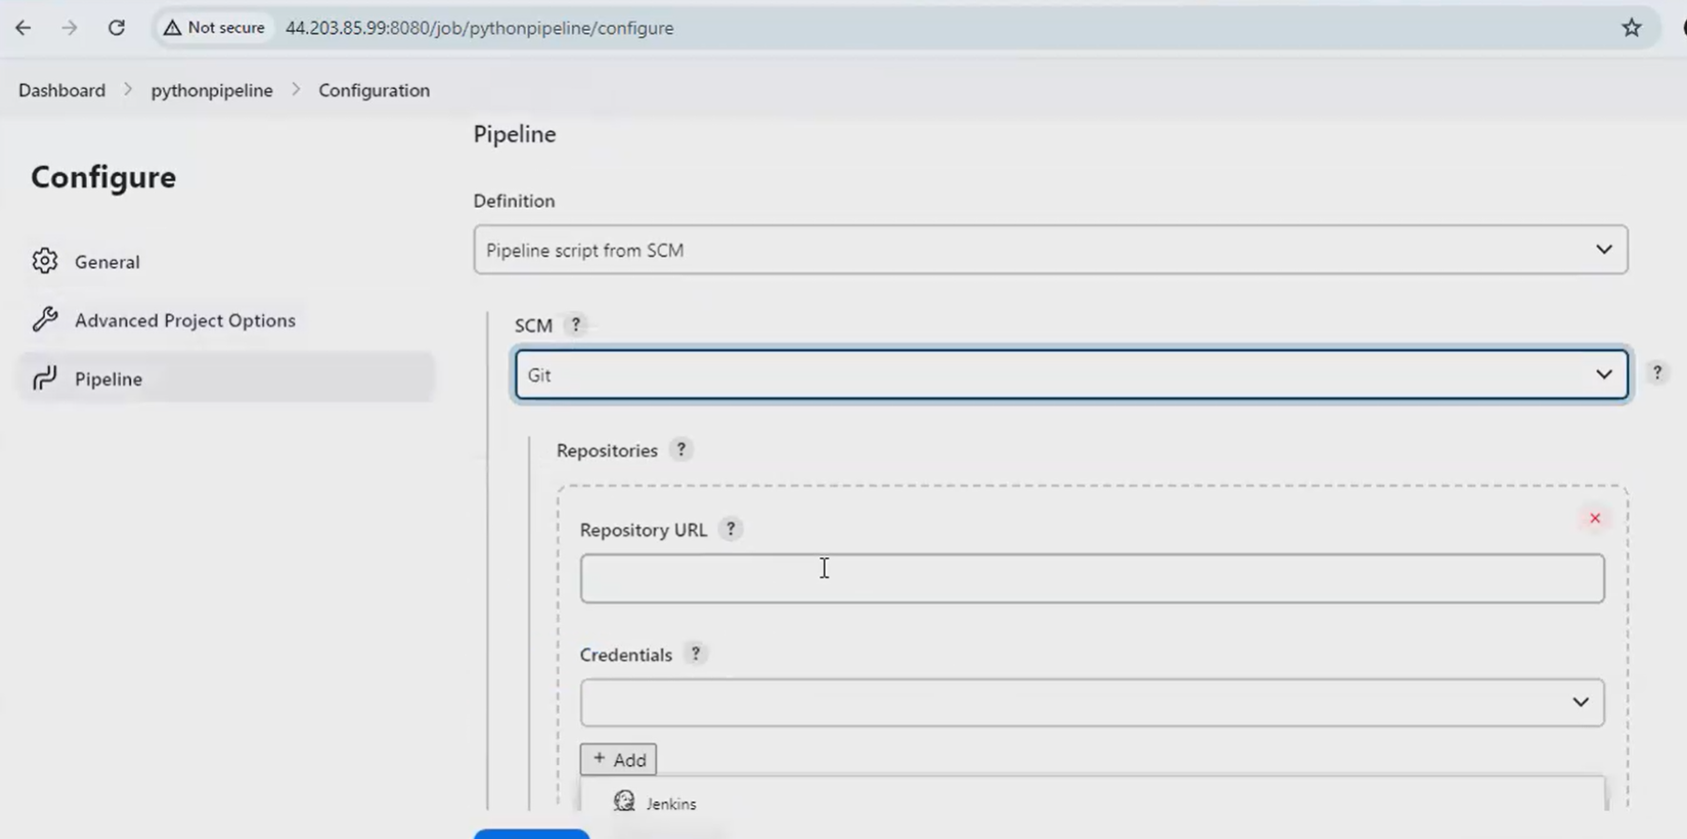

**Adding the environmental variables,**

Go to Manage Jenkins 🡪 Click System 🡪 Global Properties 🡪 Environmental variables 🡪 Add 🡪 Provide the env. Variable under Name field

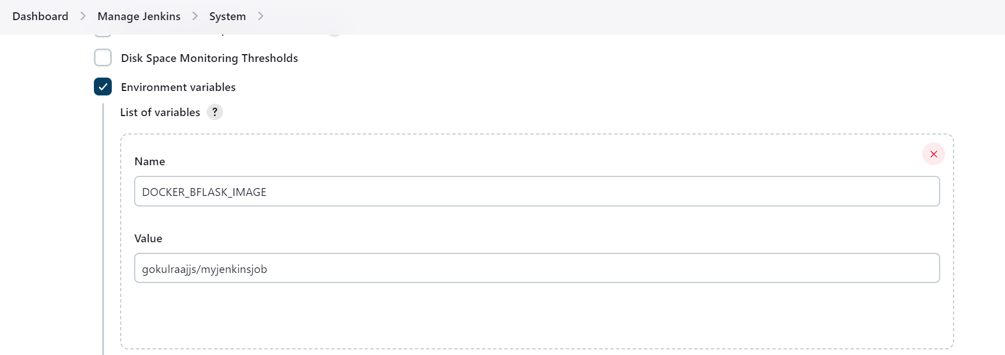

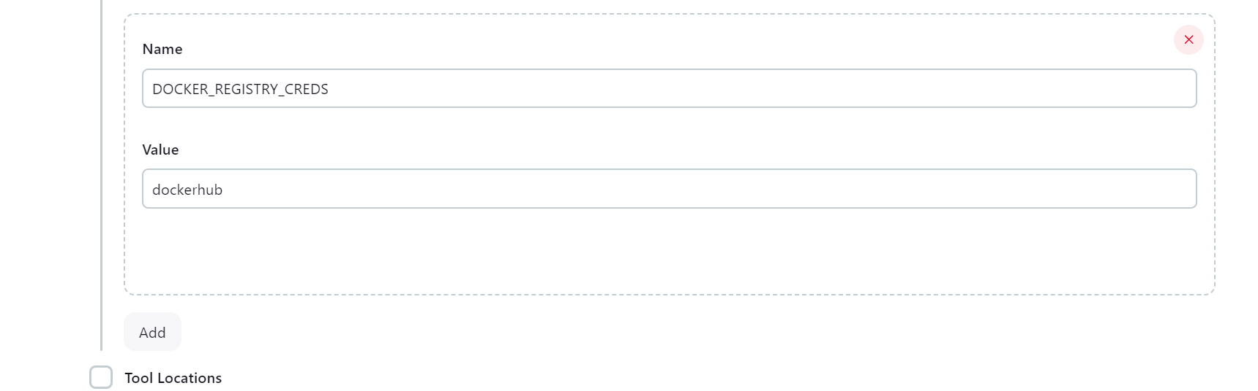

Add Docker plugin

**Linking the docker hub with Jenkins pipeline:**

Go to Dockerhub 🡪 Security 🡪 New Access Token 🡪 Generate token 🡪 Go to Jenkins 🡪 Manage Jenkins 🡪 Credentials tab 🡪 System 🡪 Global Credentials 🡪 Add Credentials 🡪 Fill the username of the dockerhub under username 🡪 Paste the Token on the password box 🡪 Fill the value that was provided for env. variable in the ID Box

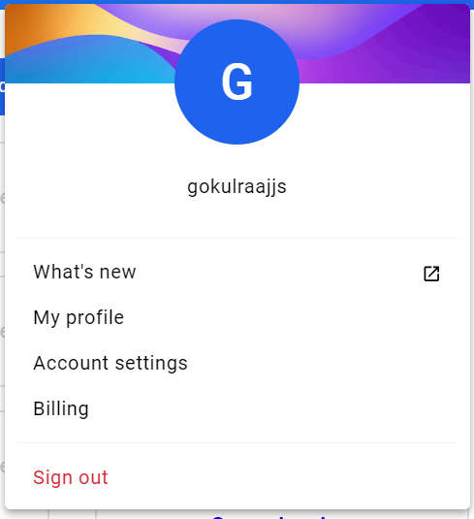

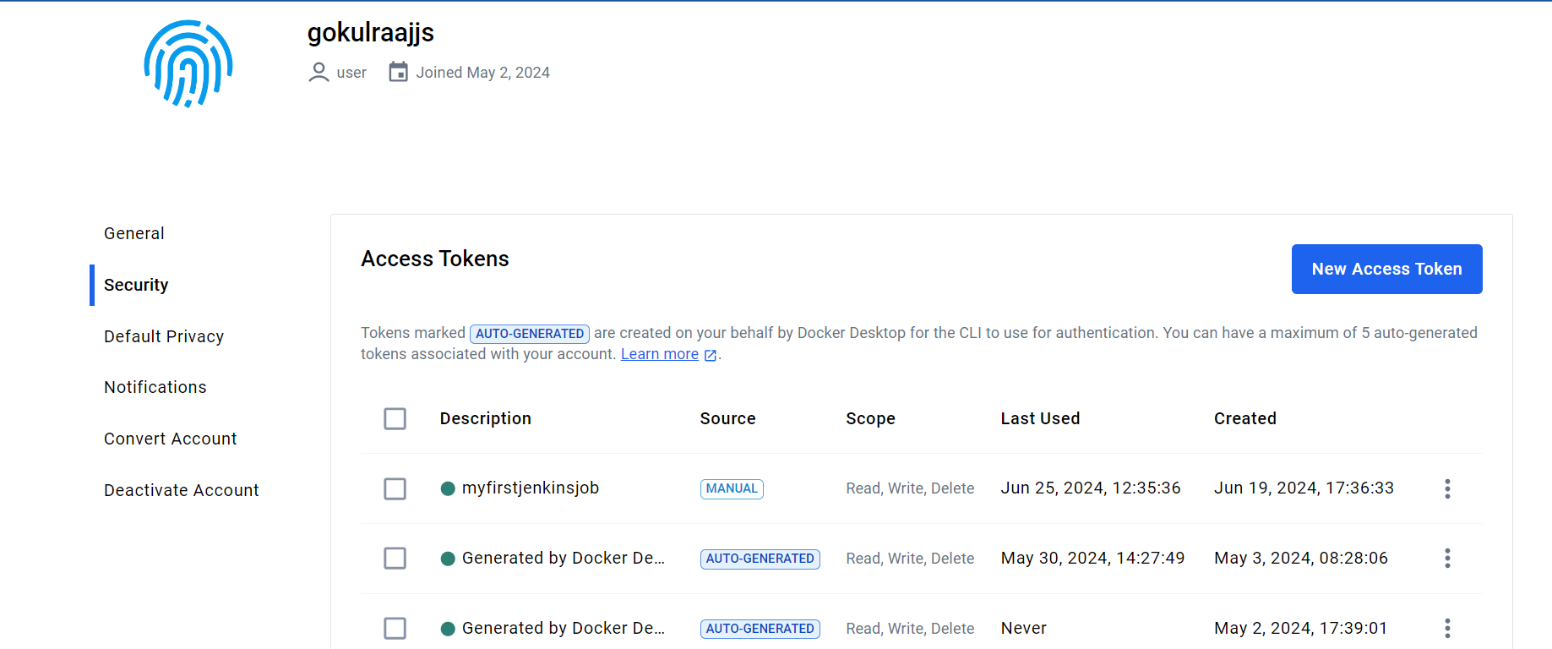

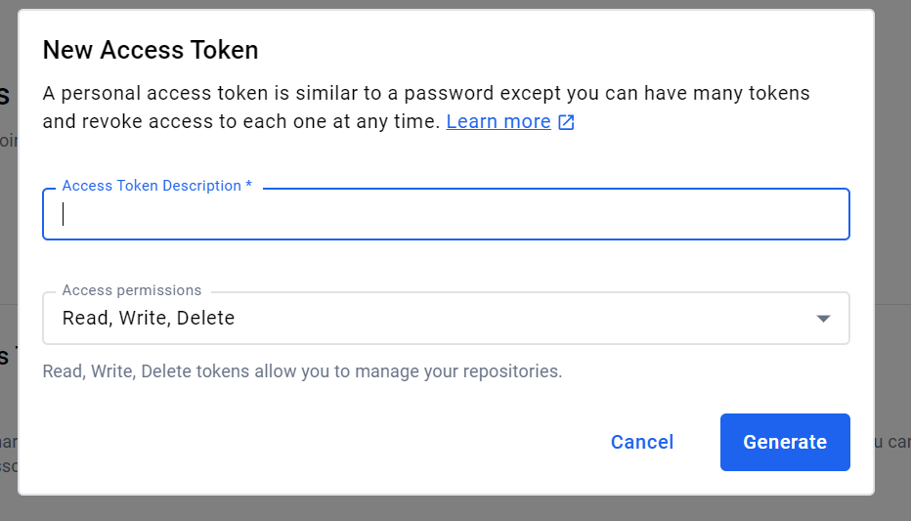

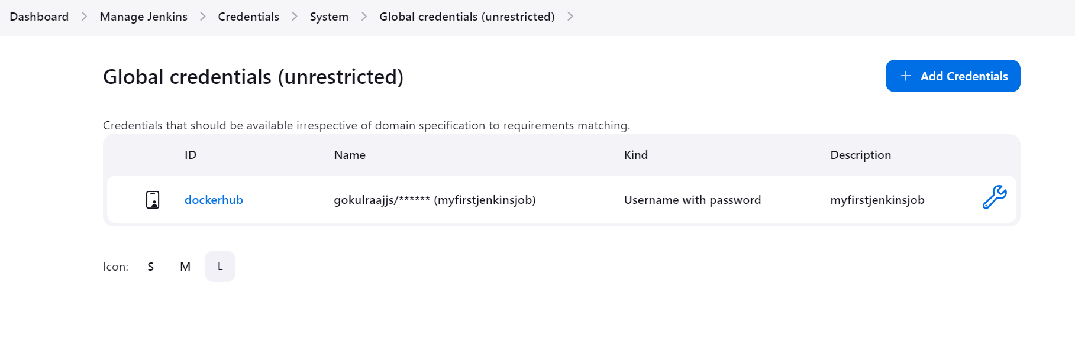

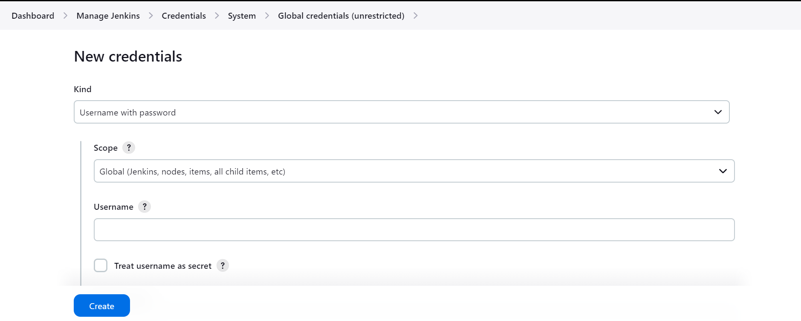

**Configuring Automatic build, if push is made:**

Go to Github repository 🡪 Webhooks 🡪 add webhooks 🡪 In payload URL, paste the Jenkins url i.e., EC2 instance Io with Jenkins port number (eg., <http://44.2033.85.99:8080/github-webhook/>) 🡪 Select the content type as Json 🡪 Add webhook

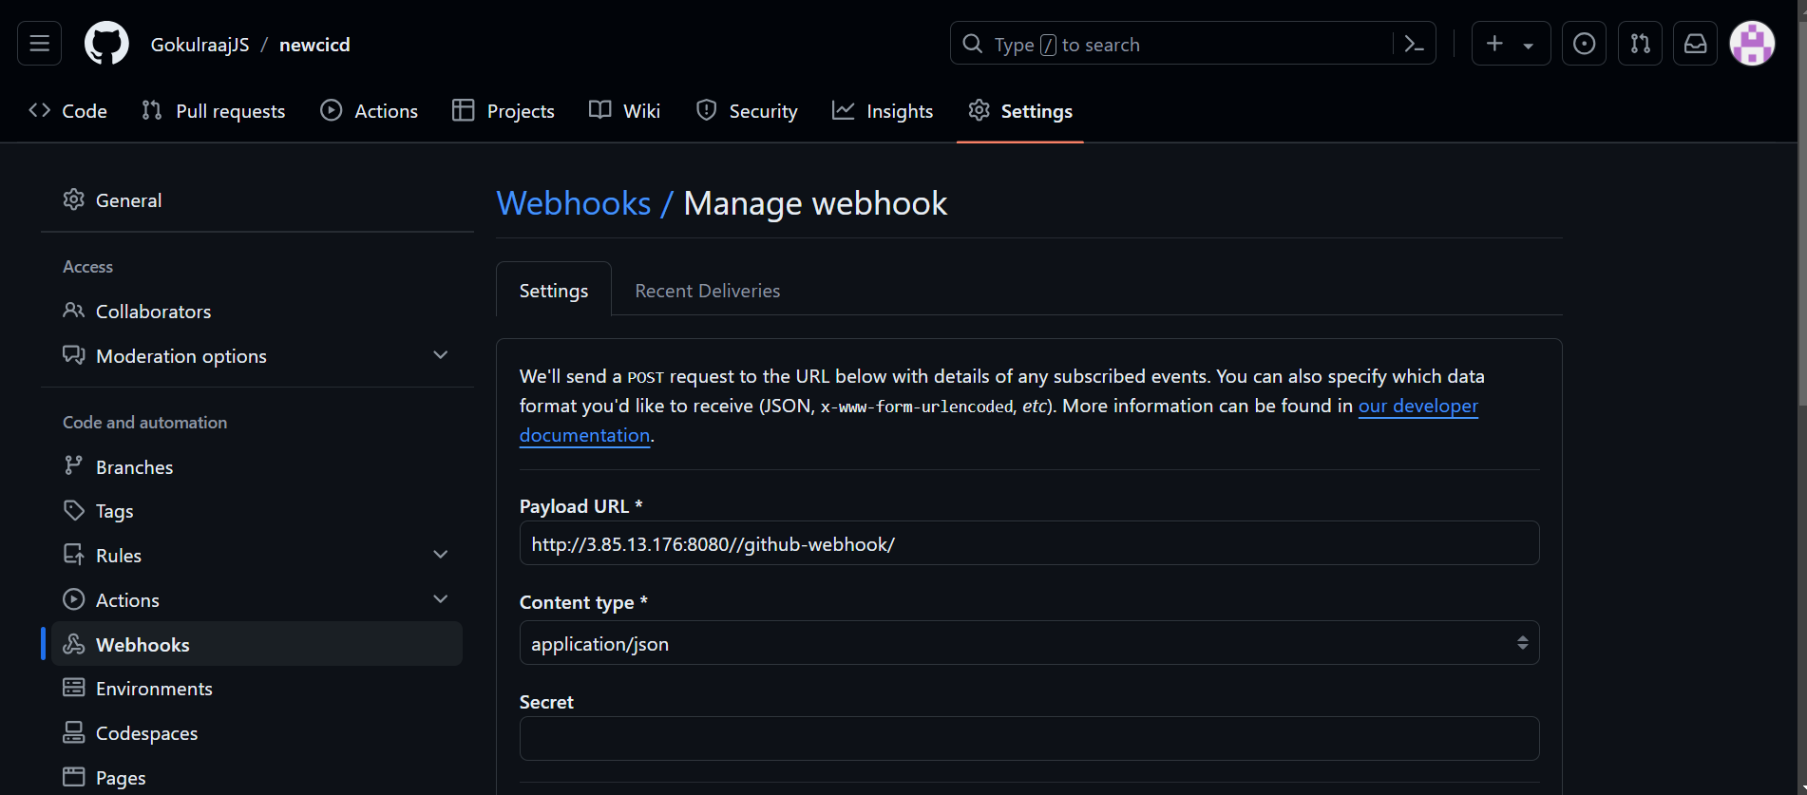

**Configuring email notification:**

Jenkins 🡪 Manage Jenkins 🡪 Plugin 🡪 Install “Email extension plugin” 🡪 Google accounts 🡪 Click on Accounts 🡪 Security 🡪 2 Step verification 🡪 Turn On 2 step verification 🡪 App password 🡪 Add “Jenkins” 🡪 Copy Token

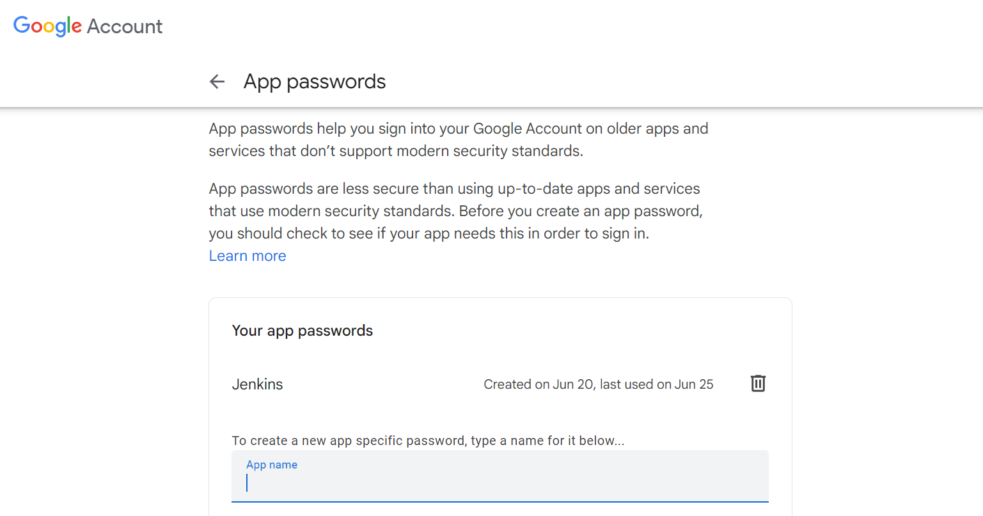

Manage Jenkins 🡪 System 🡪 E-mail Notification 🡪 Provide the SMTP Server 🡪 Advanced 🡪 Use SSL 🡪 Provide the SMTP Port 🡪 Use SMTP Authentication 🡪 Provide mail ID in the username 🡪 Provide the copied token in the paasword 🡪 Apply and Save

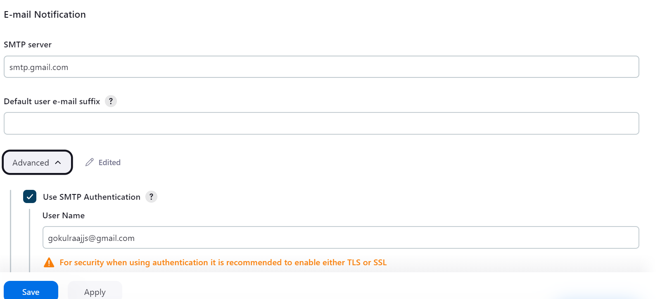

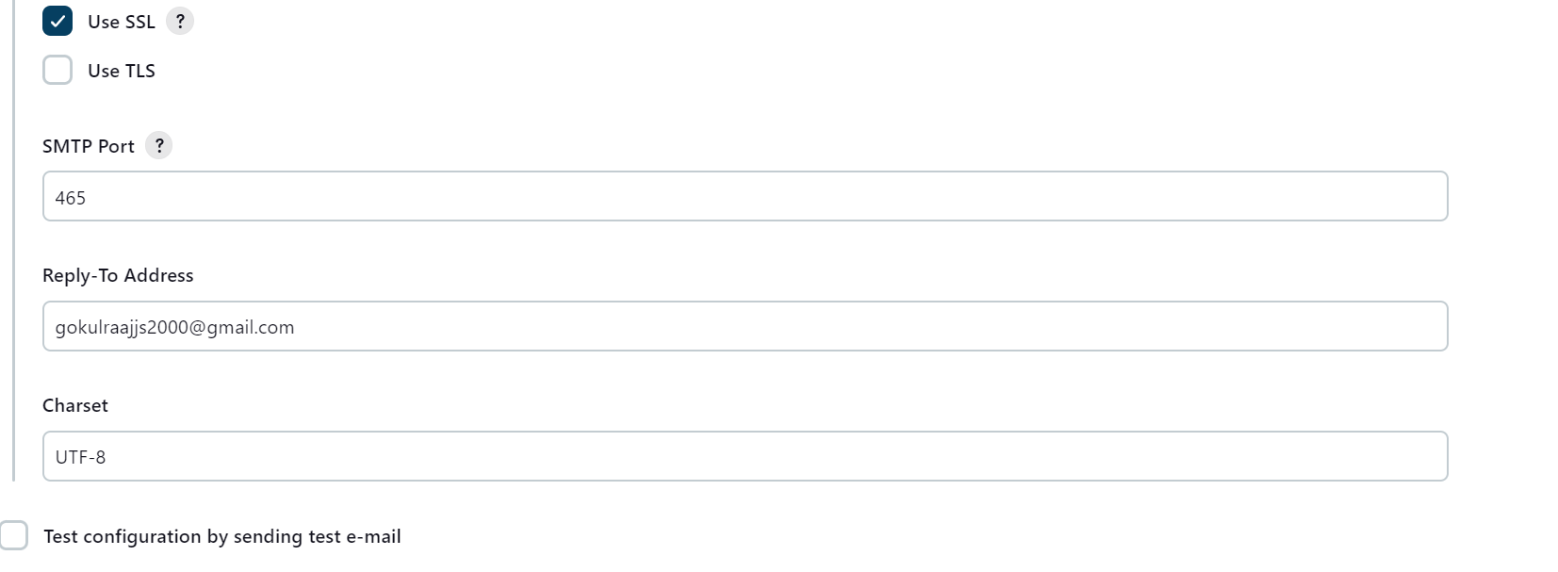

Output in the Mail:

